**Bug report 1**

*Summary:* Text Fish in the section "Phototherapy"

*Severity*: Majore

*Description*

*Environment: OS Windows 7, Browser Google Chrom, version 91.0.4472.77 (64 bit)*

Steps

1. Open the home page of the site https://cosmed.by/
2. Click on the "Услуги" section
3. Click on "Фототерапия"

*Actual result*: Text-Fish

*Expected result:* In the description the actual text on this procedure

*Attachment:* 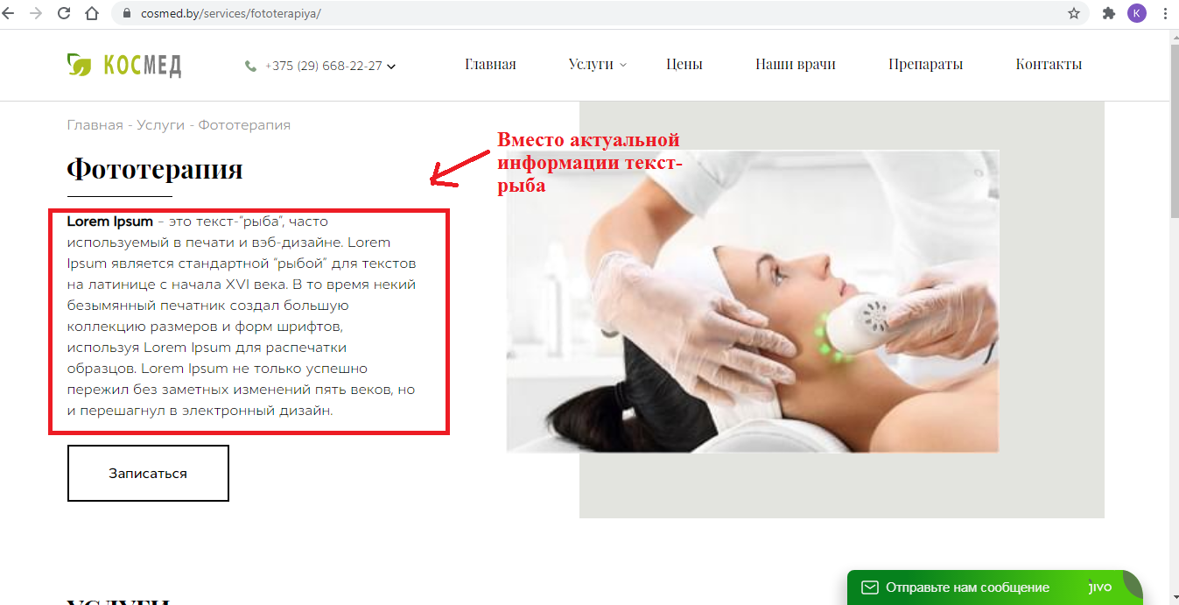

<https://cosmed.by/services/fototerapiya/>

**Bug report 2**

*Summary:* The "Terms of Use" link does not open in footer

*Severity*: Minor

*Description*

*Environment: OS Windows 7, Browser Google Chrom, version 91.0.4472.77 (64 bit)*

Steps

1. Open <https://hh.typex.one/>
2. Click on the "Terms of Use" in the footer

*Actual result*: The link is not clickable

*Expected result:* The link opens

*Attachment:*

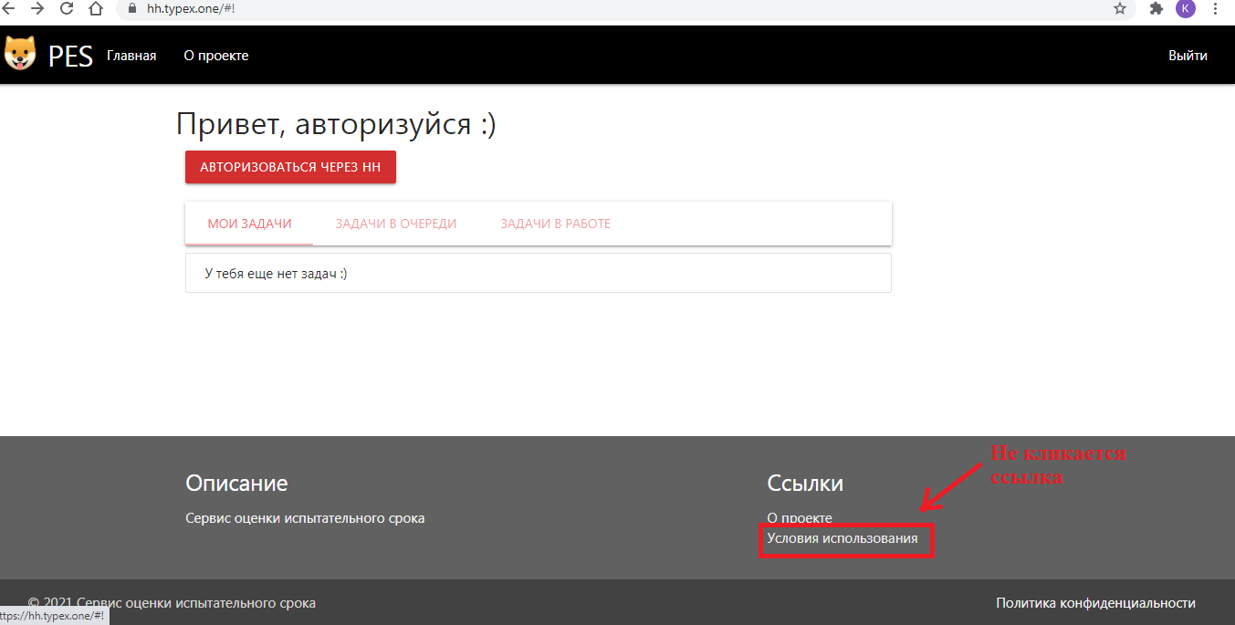

**Bug report 3**

*Summary:* «Mgpu» repository access error

*Severity*: Minor  
*Description*

*Environment: OS Windows 7, Browser Google Chrom, version 91.0.4472.77 (64 bit)*

Steps

1. Open http://mspu.by/
2. Select the "Library" section in the main menu
3. Click on «Репозиторий»

*Actual result*: Access error

*Expected result:* The "Репозиторий" section opens.

*Attachment:*

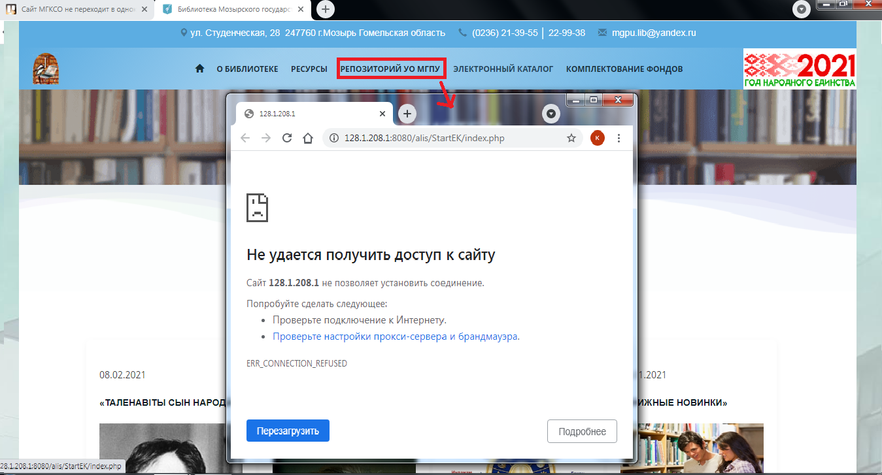

**Bug report 4**

*Summary:* On the main menu of the outpatient clinic website, when you change language, capital letters are lost.

*Severity*: Trivial  
*Description*

*Environment: OS Windows 7, Browser Google Chrom, version 91.0.4472.77 (64 bit)*

Steps

1. Open <https://10gp.by/>
2. In the header (language tab) select the icon with the Belarusian flag

*Actual result*: The website page has been translated into Belarusian. There are no capital letters in the main menu.

*Expected result:* The site page has been translated into Belarusian. Sections of the main menu begin with capital letters.

*Attachment:*

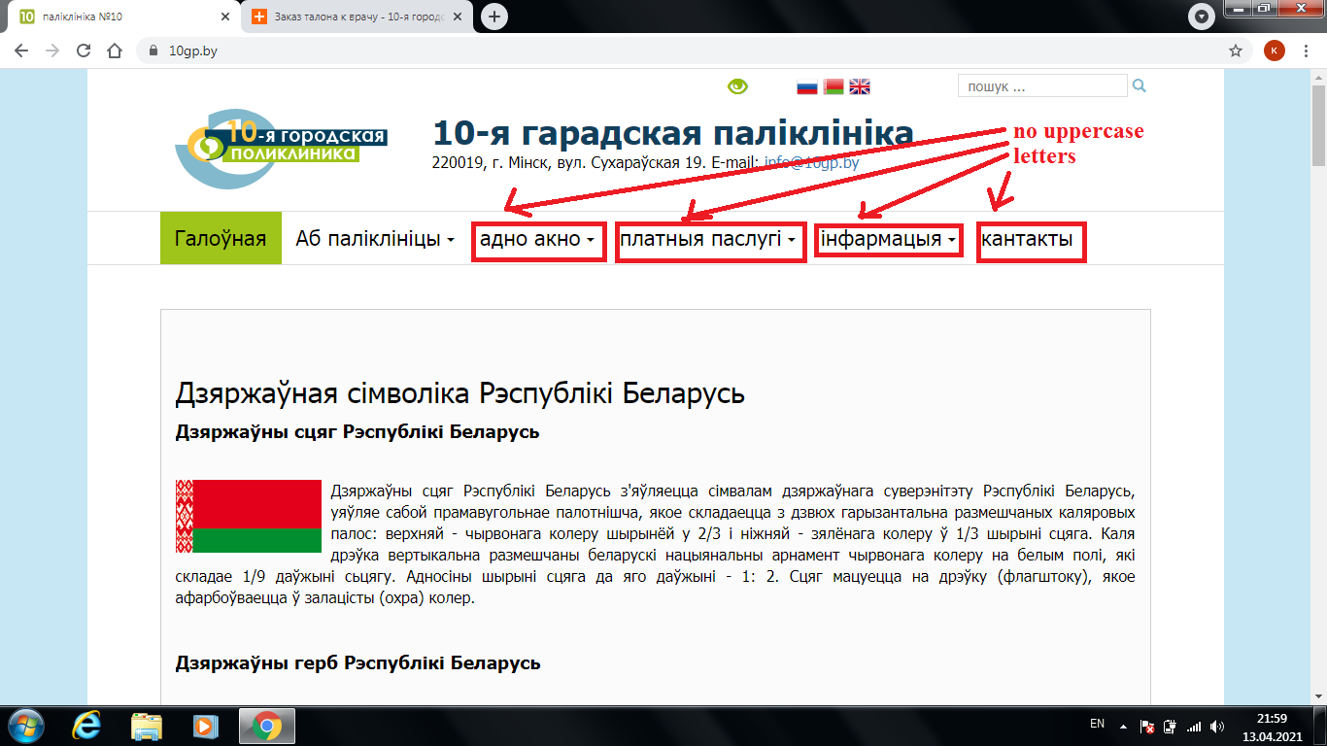

**Bug report 5**

*Summary: Wrong flag of Belarus in the currency section of «Aliexpress» mobile app Belarus*

*Severity*: Trivial  
*Description*

*Environment: Apple device, IOS, the latest version of the Aliexpress application*

Steps

Being a registered user on the aliexpress app

1. Open the "Aliexpress" app
2. Click on the profile icon in the main menu
3. Click the profile icon in the main menu.
4. Press the "Валюта" section.
5. Select "Белорусский рубль"

*Actual result*: Wrong flag next to the inscription "Белорусский рубль"

*Expected result:* The right flag next to the inscription «Белорусский рубль»

*Attachment:*

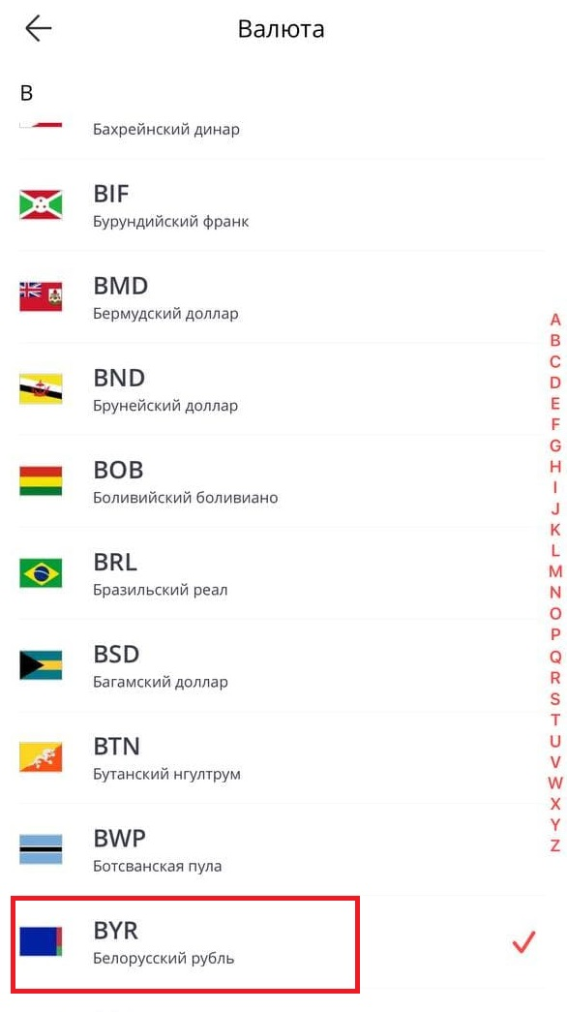

**Bug report 6**

*Summary:* Social networks widget does not direct to the ministry's Twitter page

*Severity*: Minor   
*Description*

*Environment: OS Windows 7, Browser Google Chrom, version 91.0.4472.77 (64 bit)*

Steps

1. Open http://www.mjkx.gov.by/
2. In the header, find the Social networks widget and click on the twitter icon

*Actual result*: Social networks widget does not direct to the ministry's Twitter page

*Expected result:* Twitter widget redirects to the ministry's Twitter account

*Attachment:*

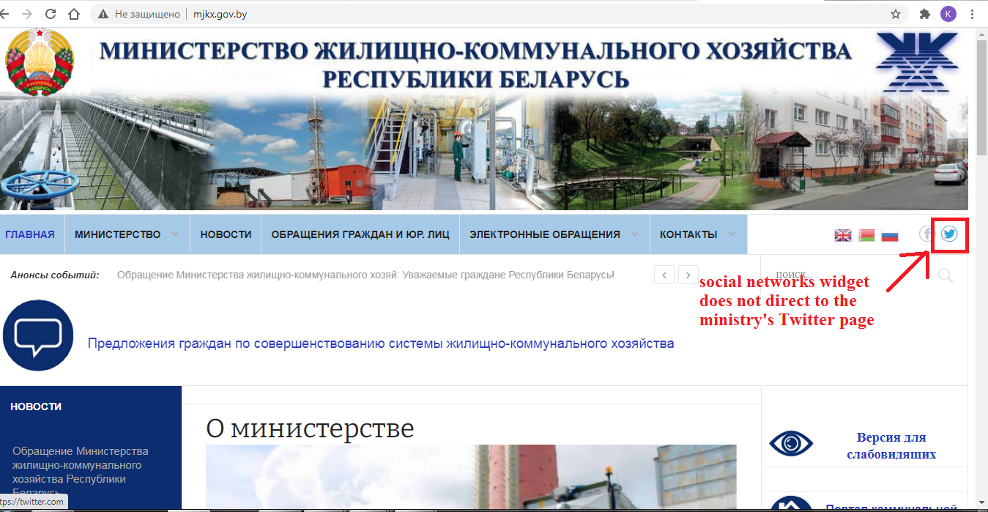

**Bug report 7**

*Summary:* Layering text on the home page

*Severity*: Trivial  
*Description*

*Environment: OS Windows 7, Browser Google Chrom, version 91.0.4472.77 (64 bit)*

Steps

1. Open https://transimperial.ru/
2. Find the "Новости компании" section on the home page

*Actual result*: Text overlay on the home page in the «Новости космании» section

*Expected result:* The text is arranged correctly without layering.

*Attachment:*

